**LockedMe.com**

Software Specifications Document

**1. INTRODUCTION**

**1.1 PURPOSE**

The purpose of this application is to build a file management system for the users in Lockers Pvt. Ltd.

**1.2 INTENDED AUDIENCE AND READING SUGGESTIONS**

This project is a prototype for the file management system and it is restricted within the company premises.

**1.3 PROJECT SCOPE**

The purpose of the file management system is to ease file management and to create a convenient and easy-to-use application for users to perform basic file management operations like creating, deleting, searching a file and displaying all file names.

**2. OVERALL DESCRIPTION**

**2.1 PRODUCT PERSPECTIVE**

Display : Display all file names in sorted order

Add : Add a new file

Search : Search a file name(case sensitive)

Delete : Delete a file name(case sensitive)

**2.2 PRODUCT FEATURES**

* Product has feature that greets the user and displays available options in the app.

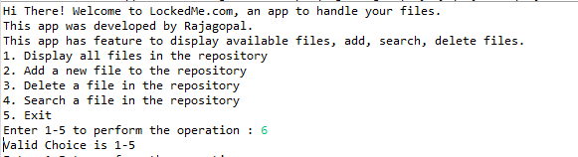

* User has flexibility to choose the desired operation by keying in the appropriate choice number. Wrong inputs are handled, and user will be prompted the same
* Option 1 will display all the files in sorted order
* 
* Option 2 will let user add a new file by specifying the file name. if the user enters a file name that is existing already, it will be notified

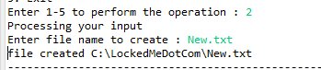

* Option 3 will let user delete a file by specifying the file name. if the user enters a non-existent file name, it will be notified

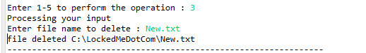

* Option 4 will let user search a file by specifying the file name. if the user enters a non-existent file name, it will be notified

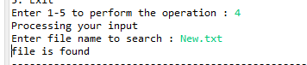

* The user has an option to gracefully close the app by choosing #5

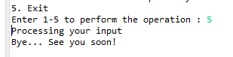

**2.3 OPERATING ENVIRONMENT**

* Any computer operating system with Java Runtime Engine(>=1.8) installed

**2.4 ASSUMPTION DEPENDENCIES**

It is assumed that all users using this application have the legal access to view or alter the files in the system. Hence no entitlement based user login system is implemented.

**3. SYSTEM FEATURES**

* **DESCRIPTION and PRIORITY**

The file management system is designed to provide a complete file management options to the user. This application is of high priority as file management forms an inevitable part in the life of users of Lockers Pvt. Ltd.

* **STIMULUS/RESPONSE SEQUENCES**
  + Display all files available
  + Add/search/delete the files by providing appropriate file names
  + All exceptions are handled
* **Flow Diagram**

NO

Enter file name

Display success msg

Yes

Yes

Exists?

NO

Enter file name

Delete File

Yes

Exists?

NO

Create File

Yes

Exists?

Enter file name

Displays all files

Exit

Invalid Choice

5

4

1

2

3

Make Choice 1-5